Case Study:17- Student Performance Trend Analysis

1. Problem Statement
Develop a Python program to analyze a student's academic performance over multiple examinations. The program should accept marks obtained in each examination, calculate the average marks, identify whether the student's performance is improving, declining, or remaining stable, and display a performance report.

2. Objectives
To record student marks across multiple examinations.
To calculate average marks and track academic progress.
To identify improving, declining, or stable performance.
To display the student's performance trend clearly.
To help identify students who may benefit from additional academic support.

3. Assumptions
Marks are entered out of 100.
At least two examination marks are required to analyze a trend.
Marks must be between 0 and 100.
The first and last examination marks are compared to determine the overall trend.
If the last mark is greater than the first mark, performance is improving.
If the last mark is lower than the first mark, performance is declining.
If both marks are equal, performance is stable.
This is a simple academic exercise; comparing only the first and last marks does not capture every fluctuation between examinations.

4. Algorithm
- Start the program.
- Input the student name.
- Input the number of examinations.
- Check whether the number of examinations is at least two.
- If not, display an invalid input message.
- Otherwise, input marks for each examination.
- Validate that every mark is between 0 and 100.
- Calculate the total marks and average marks.
- Compare the last examination mark with the first examination mark.
- If the last mark is greater, classify the trend as Improving.
- If the last mark is lower, classify the trend as Declining.
- Otherwise, classify the trend as Stable.
- Display the student name, average marks, and performance trend.
- Stop the program.

5. Flowchart

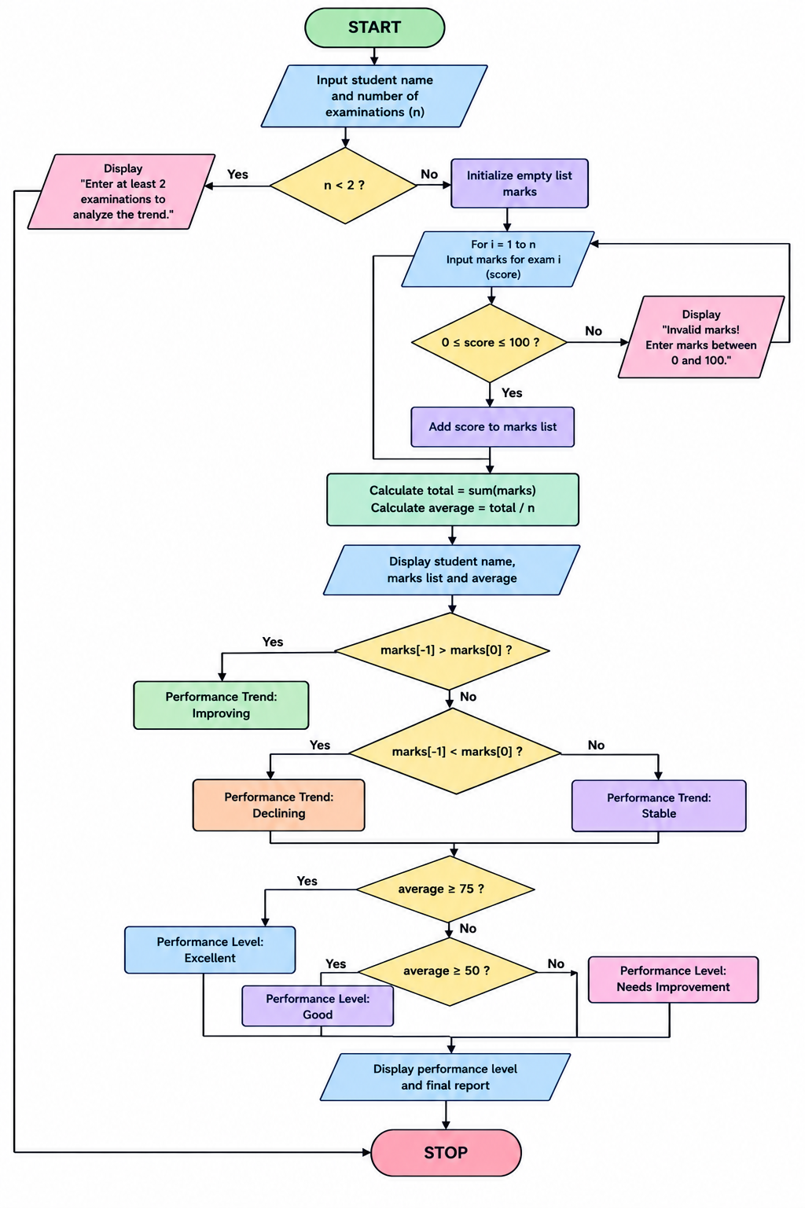

6. Pseudocode
START

INPUT student_name
INPUT number_of_exams

IF number_of_exams < 2 THEN
DISPLAY "Invalid number of examinations"

ELSE
INPUT marks for each examination

IF any mark < 0 OR any mark > 100 THEN
DISPLAY "Invalid marks"

ELSE
total = SUM(marks)
average = total / number_of_exams

first_mark = marks[0]
last_mark = marks[number_of_exams - 1]

IF last_mark > first_mark THEN
trend = "Improving"
ELSE IF last_mark < first_mark THEN
trend = "Declining"
ELSE
trend = "Stable"
END IF

DISPLAY student_name
DISPLAY average
DISPLAY trend
END IF
END IF

STOP

7. Test Cases
Test case | Examination marks | Expected average | Expected trend
1 | 50, 65, 80 | 65.00 | Improving
2 | 90, 75, 60 | 75.00 | Declining
3 | 70, 80, 70 | 73.33 | Stable
4 | 40, 50, 60 | 50.00 | Improving
5 | 80, 110, 90 | — | Invalid marks
6 | Only one examination | — | Invalid number of examinations

8. Output

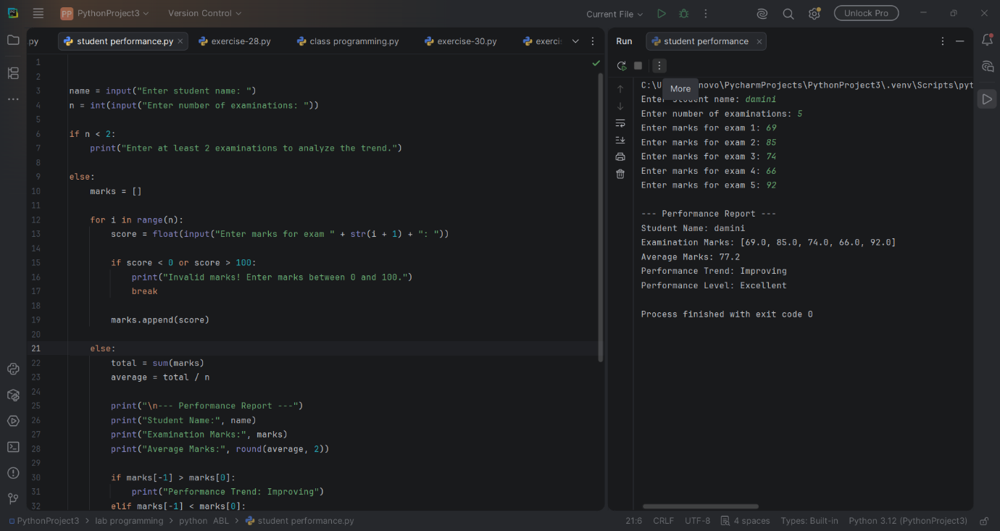

9. Conclusion
The Student Performance Trend Analysis program calculates average marks and identifies whether a student's performance is improving, declining, or stable. It uses Python lists, loops, conditional statements, arithmetic operations, and input validation. This program helps summarize academic progress and can support students and teachers in identifying areas that may need attention.

